# JavaScriptInlineCodeStep

**Objective:**

It is used to execute any custom external javascript code.

**Attributes:**

|  |  |
| --- | --- |
| **Attributes** | **Description** |
| function_name | To enter the function name which need to execute |
| plugin_name | To select the plugin name |

**Sample config.json:**

{

"workflows": [

{

"name": "code-js-inline",

"id": 200,

"trigger": "rest",

"expression": "inline",

"method": "GET",

"steps": [

{

"type": "start",

"id": 1,

"next": {

"start": "start"

}

},

{

"inline": "true",

"src": "function multi() {return 9*6;}",

"plugin_name": "code-inline",

"function_name": "multi",

"type": "code-js",

"id": "start",

"next": {

"success": "inline-success",

"failure": "hangup"

}

},

{

"variable_name": "multi",

"http_response_code": "200",

"response_content_type": "text/html",

"value_type": "hb",

"type": "send",

"id": "inline-success",

"next": {

"success": "hangup",

"failure": "hangup"

}

}

]

}

],

"filters": [],

"server": {},

"plugins": [

{

"id": "8",

"type": "code-js-plugin",

"name": "code-inline",

"code": "function invokeFunction() {return 9*6;}"

}

]

}

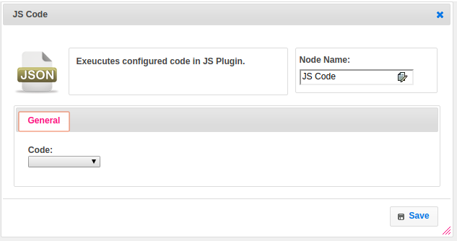

**Executor Description:**

In executor class first will get plugin code through plugin handler. Function name is null or empty then get the function name. If returned value is not map then set that value to map , where the key name is function name.